**GUIDELINES FOR ECOBALT2025**

**ABSTRACT SUBMISSION**

Author First1, Author Second2,…

1Department of Analytical Chemistry, Institution, City, Country

2Department of Aquatic Chemistry, Organization, City, State

EcoBalt2025 Conference invites the abstracts submission in the format described below, which must be submitted via the Conference Registration form. The abstract should be submitted in English in Word DOCX format. The title should be center-aligned on the page, in 14-point font size, Times New Roman, **BOLD**, and **CAPITALIZED**, followed by one line space. The author(s) name(s) should also be center-aligned on the page, in 12-point font size, Times New Roman. The first author should be the presenting author, with their first name and surname underlined, and superscript numbers should be used after the surname to indicate institution/organization affiliation. The institution/organization names should be in 11-point font size, Times New Roman, *italic*. Superscript numbers should correspond to the respective institution/organization names, which must include the institution/organization name, city, and country/state. Leave one blank line before the abstract text.

The abstract text should be justified on the page, single-spaced, in 11-point font size, Times New Roman. Figures and tables may be included, with captions in 10-point font, centered on the page. The total length of the abstract must **not exceed one A4 page,** with the following margins: top – 20 mm, bottom – 25 mm, left – 25 mm, right – 25 mm. The abstract should contain brief statements on the **Introduction, Methods, Results/Discussion, and Conclusion(s)**. All references within the text should be numbered consecutively, with numbers in parentheses, as shown here [1]. References should be listed at the bottom of the page in Times New Roman, 10-point font size, in the format indicated in the example.

Finally, include contact details for the presenting author, such as their telephone number and email, justified on the page in 10-point font size, Times New Roman.

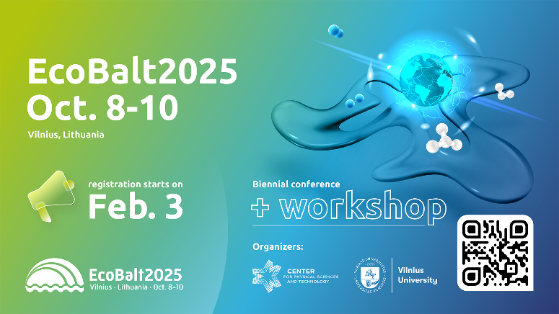

**Figure 1**. Insert figures and tables directly into the document, ensuring that images are prepared in high resolution (300 dpi).

**References**

1. MacDiarmid, A. G., “Synthetic Metals”: A Novel Role for Organic Polymers (Nobel Lecture). *Angewandte Chemie* ***International*** *Edition* **2001,** *40* (14), 2581-2590.

2. Ansari, R., Polypyrrole conducting electroactive polymers: synthesis and stability studies. *Journal of Chemistry* **2006,** *3* (4), 186-201.

**Contact person**: presenting author name, surname, phone: +370 xxx xxxxx, e-mail: Author.First@EcoBalt2025.lt.

Please upload the abstract with the file title formatted as in the example:  
**Presenting Author’s Surname_PresentationTopic_EcoBalt2025.**